

**VIRGINIA COMMONWEALTH UNIVERSITY**

**Statistical analysis and modelling (SCMA 632)**

**A6b-part(a): ARCH\GARCH MODEL**

**A6b-part(b):VAR\VECM MODEL**

**DEEPTHI ANNA ALEX**

**V01101949**

**Date of Submission: 25-07-2024**

**CONTENTS**

|  |  |  |
| --- | --- | --- |
| **Sl. No.** | **Title (Python)** | **Page No.** |
| **1.** | Introduction (Part A and Part B) | **1** |
| **2** | Results and Interpretations (part-A) | **1-9** |

|  |  |  |
| --- | --- | --- |
| **Sl. No.** | **Title (R)** | **Page No.** |
| **1.** | Introduction (Part A and Part B) | **1** |
| **2** | Results and Interpretations (part-B) | **9-11** |

**I**

**Introduction:**

In **Part A** of this assignment it is about we are checking the effects of **ARCH\GARCH model** and fitting the model. **ARCH**, or Auto Regressive Conditional Heteroskedasticity, is a statistical model used to analyze and forecast time series data where the variance of the errors is not constant but depends on past values. ARCH model is particularly useful for modeling financial time series data, such as stock returns, which often exhibit volatility clustering—periods of high volatility followed by periods of low volatility.

**GARCH,** or Generalized Auto Regressive Conditional Heteroskedasticity, extends the ARCH model to include not only past squared errors but also past variances in the volatility equation.The GARCH model improves upon ARCH by incorporating both past error terms and past volatility terms, allowing for a more flexible and comprehensive approach to modeling time-varying volatility.

We are not modelling the actual values but the volatility in ARCH and GARCH.

In **Part B** of this assignment is about **VAR VECM Model**

### Vector Autoregression (VAR) Model

The Vector Autoregression (VAR) model is a statistical model used to capture the linear interdependencies among multiple time series. Each variable in a VAR model is expressed as a linear function of past values of itself and past values of all other variables in the system. It is commonly used for analyzing the dynamic impact of random disturbances on the system of variables, making it valuable for forecasting and understanding the relationship between time series data.

### Vector Error Correction Model (VECM)

The Vector Error Correction Model (VECM) is an extension of the VAR model that is used when the time series data are cointegrated, meaning they have a long-term equilibrium relationship despite being non-stationary individually. The VECM incorporates error correction terms to adjust the short-term dynamics of the variables to converge towards the long-term equilibrium. This makes the VECM particularly useful for modeling and forecasting long-term relationships in economic and financial time series.

VAR/VECM Workflow

1. Start with Time Series Data (CRUDE_BRENT, MAIZE, SOYABEANS)
2. Unit Root Test

* **Stationary at Level**
* Proceed with VAR Analysis
* **Not Stationary**
* Test for Stationarity at First Difference
* Johansen's Co-Integration Test

1. If Co-Integration Exists:

* Determine Lag Length
* Conduct Co-Integration Test
* Build VECM Model

1. If No Co-Integration:

* Perform Unrestricted VAR Analysis

1. Post VAR/VECM Analysis

* Granger's Causality Test
* Impulse Response Function (IRF) and Variance Decomposition (VD) Analysis

1. Forecasting
2. Output

**Results:**

**PART-A (python)**

In ARCH\GARCH we need a variable\ features that resembles the volatility.

Wild fluctuations (volatility) when standard deviation is high, variance is high

The features that represents the volatility are:

* Differencing time series magnitude of difference between two values.
* Log (difference)

In the first part of the assignment I have take the data from **yfinance** of the company **TATA MOTORS.**

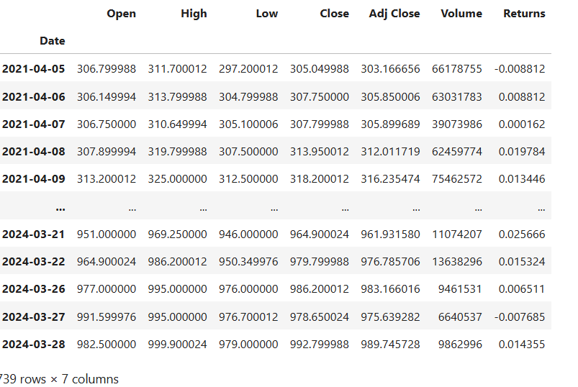

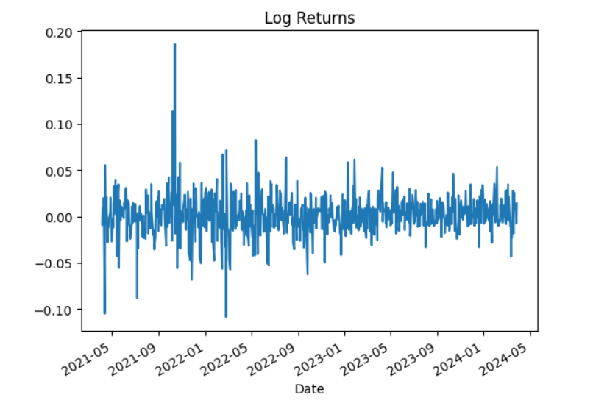

**Volatility Clustering**:

* The plot shows periods where returns are more volatile (large spikes) and periods where they are less volatile (smaller fluctuations).
* High volatility periods are followed by more high volatility, and calm periods by more calm periods.

**Spikes**:

* Noticeable large spikes (like around early 2022) indicate sudden large changes in returns.

### Conclusion:

* The graph displays volatility because there are visible fluctuations and clustering of high and low volatility periods. This pattern is common in stock returns and indicates changing market conditions.
* **Returns is the one variable that will resemble the volatility**

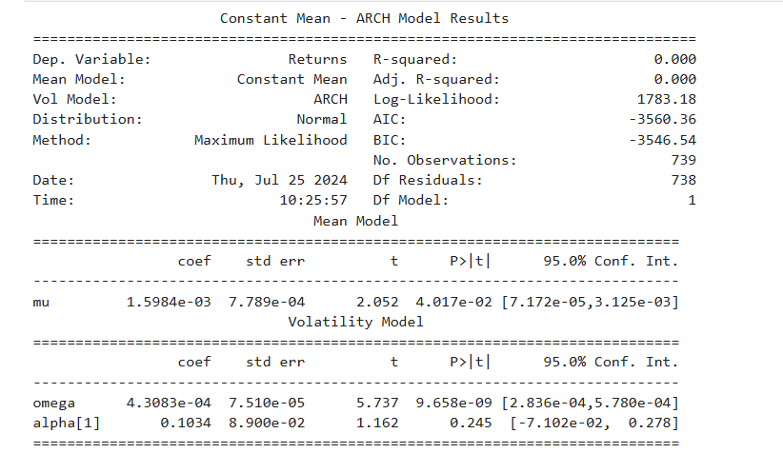

The model used is constant mean

Volume module is ARCH

Distribution is normal

P=1 which is alpha[1]

And p-value= 0.245 this value is greater than 0.05 So, the value 0.245 is not significant.

AIC= -3560.36

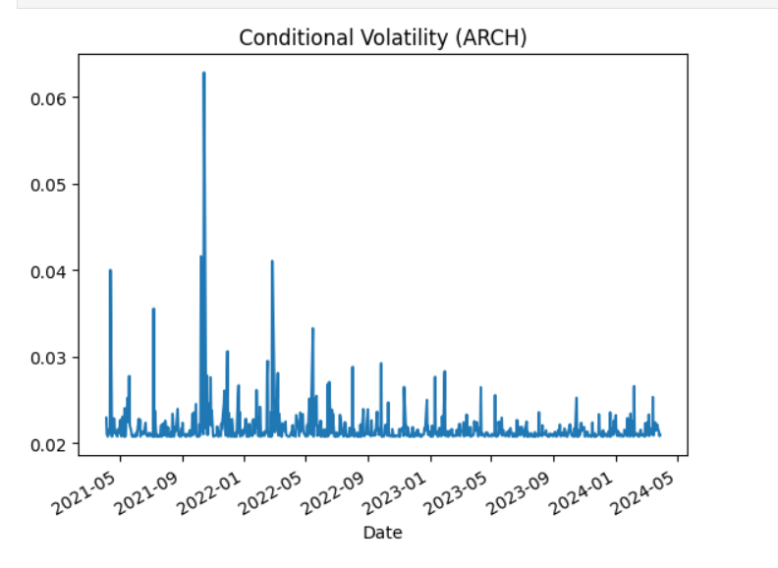

1. **High Volatility Periods**:

The graph shows spikes, especially around late 2021 and early 2022, indicating periods of high volatility.

1. **Low Volatility Periods**:

There are flatter regions with fewer spikes, indicating periods of lower volatility.

1. **Volatility Clustering**:

High volatility periods tend to cluster together, as seen with consecutive spikes.

### Conclusion:

The graph indicates that volatility varies over time, with noticeable periods of both high and low volatility. This pattern is captured by the ARCH model.

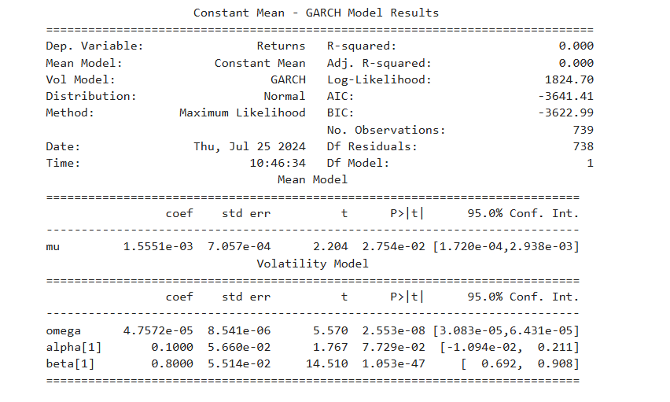

Mean model is constant mean

Volume model is GARCH

Distribution is normal

P=1 which is Alpha[1]

Q=1 which is Beta[1]

* P-value 7.729×10−2=0.07729

0.07729 is not less than 0.05; it is greater than 0.05.

* Q-Value 1.053×10−47 is an extremely small number, almost zero.

AIC= -3641.41

**Less than 0.05 p or q value would be significant.**

* So in ARCH there is only one P-value which is alpha(1) and in GARCH there p-value and q-value which is alpha(1) and beta (1).
* AIC value in GARCH is less than ARCH So lower the value in AIC in ARCH or GARCH is better the model.

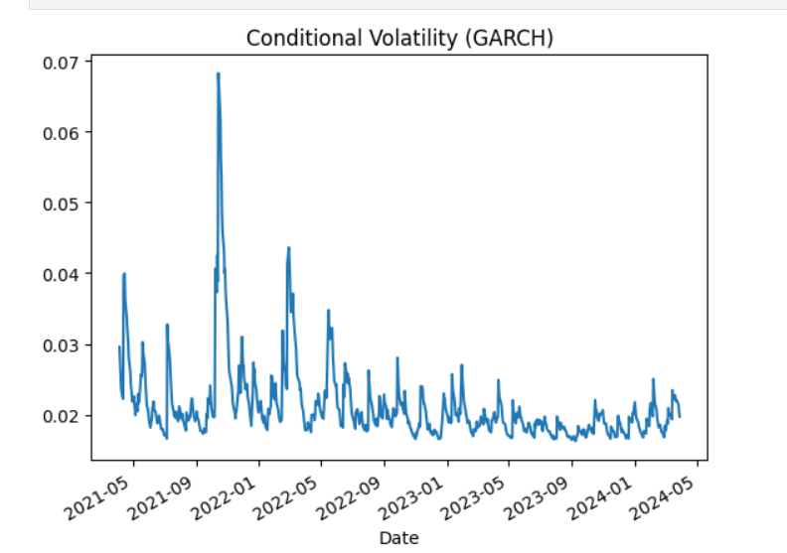

The conditional volatility depicted in the graph shows a high level of volatility around early 2022, with a peak exceeding 0.06. After this period, the volatility generally decreases and stabilizes, with minor fluctuations, maintaining lower levels through mid-2024.

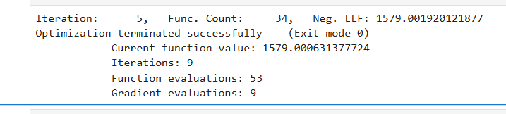

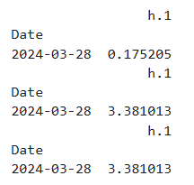 mean= 0.175205 residual variance= 3.381013 variance= 3.381013

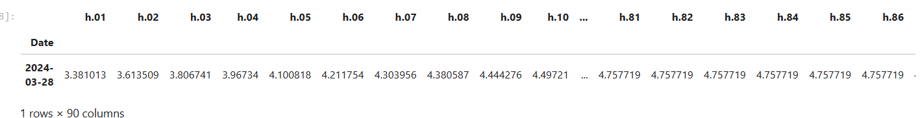

Volatility values for 3 months

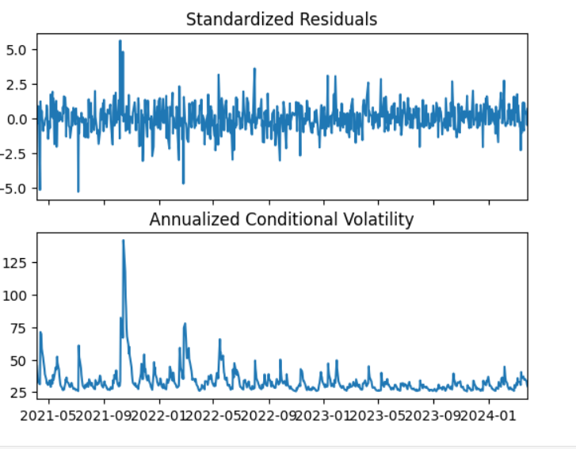

1. **Standardized Residuals (Top Plot):**

This plot shows the standardized residuals over time. The residuals fluctuate around zero, indicating the difference between observed values and model predictions. The residuals mostly stay within the range of -2.5 to 2.5, suggesting a relatively stable error margin with occasional spikes.

1. **Annualized Conditional Volatility (Bottom Plot):**

This plot shows the annualized conditional volatility over the same time period. The volatility peaks significantly around early 2022, reaching values above 125, indicating a period of high market uncertainty or turbulence. After the peak, the volatility

generally decreases, maintaining lower and more stable levels through mid-2024, with some minor fluctuations.

In summary, the standardized residuals indicate stable model performance with some variability, while the annualized conditional volatility highlights periods of high market uncertainty, particularly around early 2022, followed by a period of relative stability.

**PART-B (R-code)**

* In part B assignment the data is taken from world bank pink sheet data.
* The VECM and VAR is a multivariate model.
* A multivariate model is a statistical model that analyzes and makes predictions based on multiple dependent variables simultaneously, capturing the relationships among them.
* Machine learning models (time series model into regression )

1. In the pink sheet there is no name for the date column so we

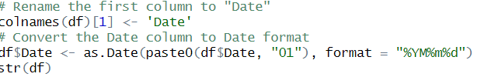

We use this code to rename the date column.

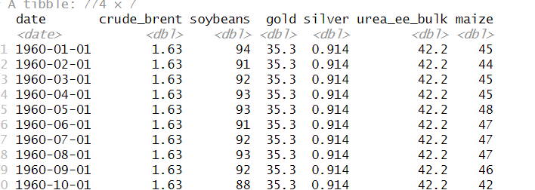 these are the variables that is been selected for the VAR VECM model

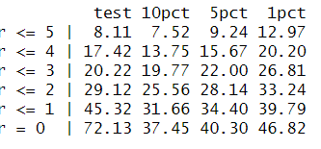 the **r=3** because in 5pct 22.00 and the test value is 20.22 in which when we compare the test value is less than 5pct so we take r=3.

**It shows the significance.**

**If r is greater than 0 then it is VECM Modelling or else it is VAR Modelling**

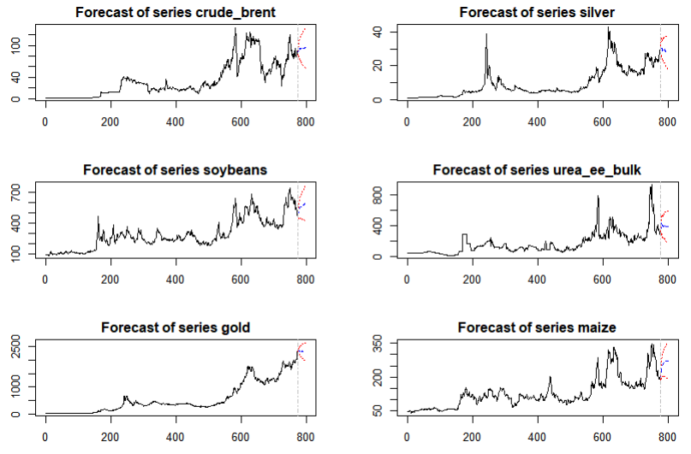

In this graph there is a blue line shown it is the **actual forecast .**

1. **Crude Brent**
2. **Silver**
3. **Soybeans**
4. **Urea EE Bulk**
5. **Gold**
6. **Maize**

Each subplot shows:

* Historical data of the respective series.
* A forecasted section marked with dashed lines or different colors to indicate predicted values.

### Key Observations:

* Each series shows a trend with historical prices and their respective forecasts.
* Forecasts generally show an upward trend in the near future for these commodities.
* The plots may have confidence intervals around the forecasted values, though this isn't clearly marked.

### VECM vs. VAR Modelling:

* **VECM (Vector Error Correction Model)** is used if there is cointegration among the variables. This means if the rank r of the cointegration matrix is greater than 0.
* **VAR (Vector Autoregression)** is used when there is no cointegration among the variables. This means if the rank r of the cointegration matrix is 0.

### Interpretation:

* If the rank r is greater than 0, indicating cointegration, VECM modelling is applied.
* If the rank r is 0, indicating no cointegration, VAR modelling is applied.

This context helps in deciding the appropriate modelling technique based on the relationships and characteristics of the data series involved.